2018

Melt My Heart Rescue & Sanctuary

Annual Report
nn

Connect With Us!
(559) 470-3098 | MeltMyHeartSanctuary@outlook.com
http://meltmyheartsanctuary.weebly.com/

3
4
4
5
6
7
8
9
9
Message from Lorelei
Mission
Programs
Bella
Cricket & Samson
Resources & Fiscal Management
Leadership
Looking Forward
Ways to Help

CONTENTS
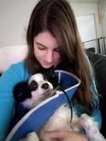
Message from Lorelei

Dear Friends and Fur family,
Building the rescue and sanctuary has been a long-time dream of mine, and with this amazing community, it has become a reality that is slowly growing in set up, outreach and impact. Our work makes a difference within the sanctuary as well as the community as a whole. We've been able to provide a safe place for many elderly and special needs beings to land and continue to live out their lives. These residents have bonded to the amazing group of volunteers who come by and show them love while helping take care of them. We also have been able to find forever homes to those who come to us in times of need when others may not have been able to get to them in time. These forever families and adopters have grown our own family and helped make a difference.
Lorelei Kushaney, Board Chair

2018 has been a pivotal year for us as we established all the ins and outs of what works best during our first full year of operation. While we had challenges along the way, we proved our resilience and commitment to the betterment of the sanctuary and rescue, and all the animal's lives that we touched, by persevering and finding solutions for improvement long term. We have now created a foundation for ourselves and are looking forward to 2019 with major projects in the works that will ensure generations of positive impact within the sanctuary and the community. We can't thank you enough for the support during these early and most difficult years.

I, as have all the board members, dedicated our lives to providing the love, care, and safety for all species of animals who come through our doors and passing on our compassion and empathy to future generations. My dedication to my life's work is only possible thanks to the support you provide to us all both in donations as well as in time and love.

Lorelei Kushaney
Mission
Our aim is to re-home animals when appropriate, train permanent residents for volunteer therapy, and care for special needs or retirement animals for the duration of their life when necessary. We hope to bring awareness and education to the public about all animals and their needs. We are a 501(c)3 non-profit.
Programs
Adoption
Every animal deserves love. Especially those abandoned or released due to unforeseen circumstances. Not only do animals give unconditional love, they have been shown to psychologically, emotionally and physically benefit their companions. Caring for a pet can provide a sense of purpose and fulfillment and lessen feelings of loneliness. It is our job to assure that the pet decides what family they will choose to love. And we take that job seriously. We are lucky to have a founder with an innate skill of understanding when an animal has made their choice and is willing to work hard until that choice is made!
Pet retention program
We offer a sponsorship program to help protect the familial bonds between great pet owners and their fur, feathered or scale family members while they're going through difficult temporary situations. Whether this be in the form of temporary fostering of a loved pet, or a sponsorship of food and other supplies during a financial crisis, help is available.
Pet-loving, Highly Skilled Fosters
Our fosters are long term pet lovers who understand the patience and positive reinforcement needed to help rehabilitate and socialize each of our intakes. We are always in need of fosters and welcome training and mentoring new fosters, our fosters know that when in doubt they can contact one of our trusted vets or board members for advice and support. In addition, our fosters and board members are eager to keep in touch with adopters and offer mentor-ship.
Sanctuary
Sometimes our residents are not able to choose a new family due to health issues or special needs. Those special beings are welcomed into the Melt My Heart sanctuary to live out their days in peace while being loved and well cared for. Our sanctuary is diverse with all types of animals living in harmony and loved without abandon by our founders and volunteers.

Success Stories
2018 was our first full year in operation and we saw many wonderful things happen. Here are a few Success stories.

Emmie becomes Tetra <3
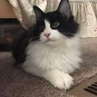
Tetra was one of four kittens in need of a rescue or at risk of death from anemia and permanent leg defects. Luckily, she was surrendered early enough to have no long-lasting negative effects on her health, legs or otherwise. She and her siblings were picked up and taken into vet care immediately that same day.
Tetra was by far the most playful of the bunch at first and showed all the other kittens the ropes. She played hard, then crashed out hard. Her hunting “skills” weren’t that amazing but her tiny butt wiggle surely were! She loved a snuggle with a little playing in between. She quickly grew to be a lovely lady with medium to long gorgeous black and white fur and big golden/green eyes.
When she went up for adoption, at first, she had lots of people love on her and stole hearts but couldn’t seem to find the home with room to welcome her. She went for her final shots visit at the vet office and all the vet techs swooned and took pictures of her adorable fluffy face.
That was what did it! The vet tech who came in the next day quickly contacted the rescue and asked if the kittens were still available, which Tetra obviously was because she was waiting for her! No wonder Tetra hadn’t been immediately swept up, her mom was right there!
They met and originally her mom was hesitant but couldn’t help the immediate bond. Tetra went home and it wasn’t long after that the whole family was on board with adopting her! The adoption was finalized, and Tetra went on the drive with the rescue owners to go to her new home. When they pulled up the adorable faces of her new human siblings were all patiently waiting by the window to welcome her.
Tetra was a little nervous at first with all the attention and new smells, but her human siblings let her settle in patiently and made her feel at ease. She also had fellow kitty siblings who showed her the ropes and took her under their paw. Now she’s a full-fledged member of the entire family four legged or two legged and couldn’t be happier! It turned out to be a match made in heaven for her older paw siblings and her human kiddos. We couldn’t be more overjoyed for Tetra’s match <3

Spanky the turtle
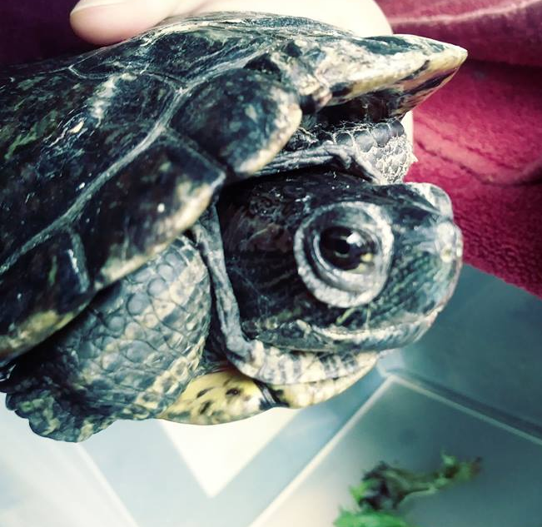
Spanky was quite the little turtle who is a fighter and survivor. His owner unfortunately ended up in an extended hospital stay and was unable to return home for care for her animals. Her friend was able to step in and due to the length of recovery and inability to care for him Spanky needed a new home. At this point though he’d gone without care for some time so that friend rushed him into emergency care.
Vets were able to provide him with around the clock care, treatment, medications, feedings and cleanliness. The bill was being taken care of by the friend, but it quickly added up and she needed a rescue to step in and finish his recovery. Melt My Heart drove out and picked him up and continued his post care and regular injections and watched him flourish to returning to a healthy swimmy little turtle.
Spanky quickly found a home being an indoor tank and outdoor pond turtle enjoying the best of both worlds. He was excited to never have to get a shot again and swim his way out the door into his new family. We are happy to say Spanky found a pond worth claiming as his own.

Snow the cockatoo
​Cockatoo’s are HUGE personality birdies, with a LOT of vocal capabilities. They pick who they love and who their partner will be throughout their life. They are basically like owning a “toddler” for the rest of your life and often outlive their owners as their lifespan can be 70+ years.
Unfortunately, Snow had an amazing family for the first 13 years of her life when she went through that loss. Suddenly she had no family and found herself waiting for a new family, mourning her losses. She’d had a fellow feathered sibling who she was separated from and she quickly shut down.
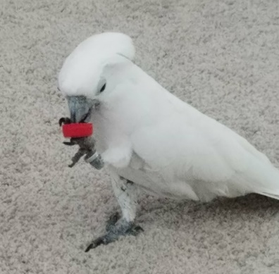
After being picked to go home with the founders of Melt My Heart she quickly took to being a cuddle bug, followed by feeling comfortable enough to show off her vocals and sometimes bossiness. She would get possessive sometimes of the humans, but she was working on her manners every day.
She learned to like a new healthy diet and fresh chop, but definitely retained her love for unhealthy foods too. Snow once was riding in the car and recognized that the humans had stopped at one of those “drive through places.” When she realized these humans were unaware of the pact her previous family had with her, she let them hear it! Didn’t they know she was to ALWAYS get a French fry from a drive through?? Well she sure let them know! She also has a love of a piece of macaroni. I guess every’birdy’ has to have their vices, right?
After a long wait looking for an experienced owner and fellow family members to care for her, who would also ensure that if anything were to happen she’d have the rescue as a backup, she finally found her match. A lovely woman came to visit her and instead of her normal standoffish self, Snow was immediately all over and cuddling her and cooing. The adoption proceeded, and Snow has had a happily ever after since!

Green Machine
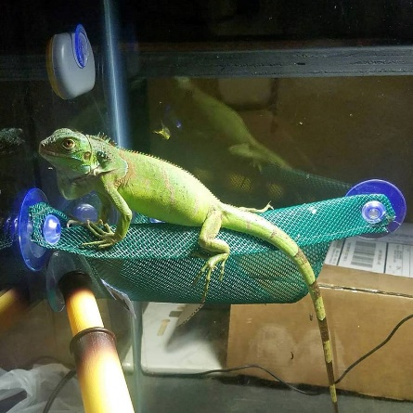
​Green Machine ended up falling into a woman’s lap and she had no idea how to care for him. She realized he wasn’t doing well and took him to a local shop who got him into the rescue. At first, he seemed to have little personality and almost no energy. He wouldn’t eat, he hardly moved, and he was bone thin for his age, or really most any age.
Immediately he was provided the necessary husbandry and care, including working up his appetite and helping him settle into a new environment. Naturally he began to give some tail whips of insecurity as he gained his energy and confidence back but quickly got to know the caretakers and fellow pets and calmed down. He gained weight at a drastic pace and followed it up with a very healthy molt. All signs were good, and he quickly had a home waiting on him with humans who had ample experience, a cage, and set up prepared and the will to help him trust and bond!
They drove out quite a long ways and made sure he had a comfy ride home, updating us within the first few days of how well he adjusted and enjoyed his meals. We’re happy he found a great home, and know he’ll grow to be a nice big healthy boy!
Resources & Financial Management
The fact is there is more than just food and love required for animals, especially those with special needs. We have extensive veterinary bills as well. Every donation of supplies, food, labor and love helps divert resources elsewhere to make this rescue work.
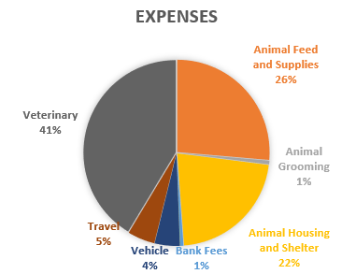
Thank You to All of Our Donors
We are eternally grateful for those who continually support us financially. It takes a true village to do this work and we are blessed to have many in that village. We have both donors and volunteers to help us fundraise, all of which help us make every day work. Every dollar that comes in takes pressure off the finances of the founders and we appreciate every single one!
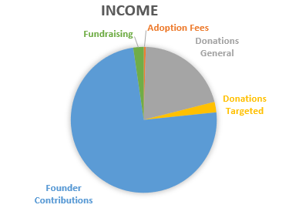

Special thank you to the business that support us!
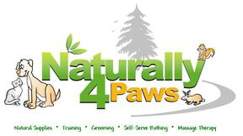
We are eternally grateful for the local organizations who help us through generous non-cash donations.

Executive Leadership
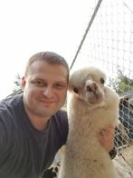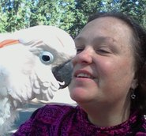
Lorelei Kushaney
Board Chair/Founder
Chele Dimmett
Treasurer

Eric Kushaney
Board Member
Lorelei has been in love with animals from the moment she was born. She began working professionally with them from the age of 12. She has worked with a vast array from exotics, birds of all types, equine, and domestic pets. | Eric has always had a heart for animals and the animals have taken to him instantly no matter what their background or fears were. He has a background of working with and boarding animals, mostly with dogs. He even grew up with 5 Great Pyrenees in the household all at once | Chele has had the heart to nurture others around her no matter it be animal or human. She is a natural at calming the nature of those in distress and can communicate directly to the heart. She has experience rehabbing parrots, as well as having owned cats and dogs
Our Amazing Volunteers
Synclair – Synclair is a lovely young woman who dedicates much of her free time to helping care for the animal’s basic needs, providing what she can for them and socialization. She has helped them learn to trust from the very beginning and they always look forward to seeing her come through the doors eagerly. We know her future will always include looking out for animals and seeing the best in all of them and helping them to find love.

Beverly – This woman has been reliable and there for the animals through and through from day one that she came, she has dedicated every Friday to helping with their care and needs in whatever way she can. She has become an integral part of our functions and the animals know her as one of their very own.

Nikita - One of the most admirable and get it done young women you will ever have the fortune to meet. She has a heart of gold and despite a busy lifestyle makes time weekly to come out and take care of the animals no matter the project.

Vincent – Nikita’s father is a soft-spoken gentleman who helps residents with fear of men see the good again thanks to his patience and kindness.
Guy – A close friend of Nikita and Vincent, who, in lieu of a busy travel schedule, joins their efforts and helps with major project work, land work, and of course loving on all the feisty kitties.

Looking Forward
2019 is bringing great things before a new decade is upon us. The slated projects for this year include, in-ground drainage additions for water maintenance, a manure station for the pasture, a pasture extension for the sanctuary residents, a new chicken abode, and a large outdoor aviary and enrichment area for the parrots!
We Need Your Help
Every Penny Matters
​We welcome donations of all kinds to help support upkeep costs of the sanctuary, prepare for new arrivals, manage vet and medical care and much more!

paypal.me/MeltMyHeartRS | www.patreon.com/MeltMyHeart
smile.amazon.com
Use code MELTMYHEART20 while you shop save 20% and automatically donate 20% | Wishlist: http://a.co/bLf4xVm
https://www.pinterest.com/kyokomitsu/animal-rescue-%2B-sanctuary-wishlist/
Top of Form
Volunteer
We always could use a few extra hands around the property helping out, whether that's to love on or socialize them, or to help clean out the cages, or even learn and assist with the grooming we welcome volunteers! We also could use some builders to help set up and maintain the property.
Foster
If you'd rather volunteer from home we always need fosters to welcome new rescues into their home temporarily when they come in need. You can apply to be a foster on file for any type of animal or species of your choosing so that when a life is in need, we're ready! Just message us for a foster application!
​
Educate
We're always looking for more people to learn about the residents and educate others as to bring awareness. Courses are coming soon that you can take in order to better educate and spread awareness of care, needs, and concerns throughout the community. We're also here to help educate you on proper care of individual animals.
Partnership
Are you a rescue or local community looking to partner? Contact us with your needs today! The more we work together, the better it is for the animals.
Sanctuary + Therapy
Are you looking for a local therapy animal group? Do you work with kids, elderly, special needs, mental health or veterans and need a friendly group of animals to come visit your community? Schedule with us today, for a session with our approved residents who can visit in the community!
Melt My Heart Rescue & Sanctuary

Thanks for a great Year!

