2017

Annual Report
nn
Melt My Heart Rescue & Sanctuary

http://meltmyheartsanctuary.weebly.com/

3
4
4
5
6
7
8
9
9
Message from Lorelei
Mission
Programs
Bella
Cricket & Samson
Resources & Fiscal Management
Leadership
Looking Forward
Ways to Help

CONTENTS
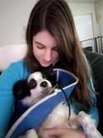
Message from Lorelei

Dear Friends,

It has been my dream to create a safe space for animals that appear to society as unwanted. My passion is special needs and elderly lives. There is no limit to what I will do to make sure an animal’s life is given the same attention, love, and resources as a human child. Melt My Heart Rescue and Sanctuary is the beginning to the realization of that dream.
2017 was MMHRS’ inaugural year and we really didn’t get started until end of Summer but during that short time we have achieved great things. We have achieved our 501c3, became known and supported by many local organizations, and have saved a number of special friends who now live at the sanctuary. We have also created processes for adoptions and have been graced with many amazing volunteers to help us achieve our goals. 2018 is going to be amazing with the things we achieved in 2017 as our foundation.
Lorelei Kushaney, Board Chair
While this message is short, our goals are not! We have so many ideas and love to give. Every day is a new challenge and a new achievement.
Thank you for taking the time to learn more about us and for your interest in our accomplishments!

Lorelei Kushaney
Mission
Our aim is to re-home animals when appropriate, train permanent residents for volunteer therapy, and care for special needs or retirement animals for the duration of their life when necessary. We hope to bring awareness and education to the public about all animals and their needs. We are a 501(c)3 non-profit.
Programs
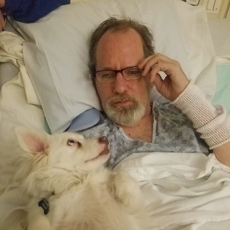
Animal Support Therapy
Animals know. They know when you are happy, they know when you are sad, and they know when you need a little extra love. Many of our residents have special needs and they know when a human also has needs. Why not bring them together? This is a brand new program where we bring selected residents to retirement homes to spend time with people who enjoy just a little extra love.

Sponsor an animal
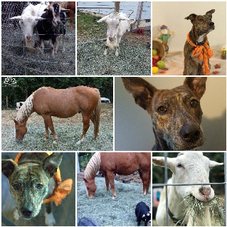
Currently we have many residents who need lifetime care and live their lives out at the sanctuary. This requires long term vetting costs, medications, grooming, toys, beds, shelters, bedding and so much more.
We couldn’t do it without the community willing to help support us. You can make a monthly donation toward the care of any of our long-term permanent residents and their needs by adding their name to your donation. We have animals of all types with all types of needs so if you can’t pick one you can also donate to the general fund, or search through the stories and find one that calls to you.
The community makes things possible and allows everyone to show these loving souls what it means to be loved and cared for finally.

Success Stories
Because 2017 was our first year in operation, and a short one at that, we do not have good data to show with pretty graphs and charts. But what we do have is a number of important Success stories. Here are just a few.

Bella the husky
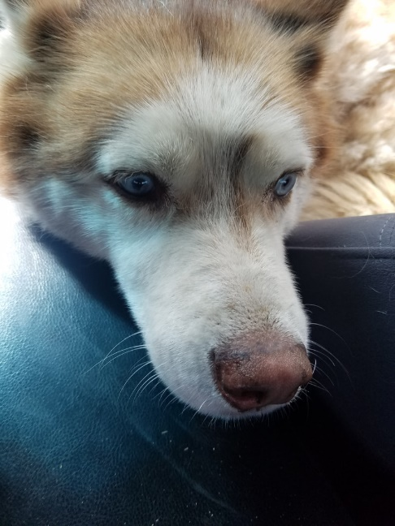
​I was a young dog once, and had a family once. As I grew older, my family became more impatience with me and my aging bones. The more my bones ached from aging the more I hurt every time they touched me. I wish they would have pet me gently with love. Still I was always happy to see everyone, I loved being with people. I was a good girl who only barked when I got excited. Why did you debark me? Why did I need my vocal cords surgically altered?
They said this procedure was to make me quieter, I guess you didn’t enjoy my natural Husky personality. What possible side effects could this have? The rougher you got with me the more I tried to tell you it hurt, I tried crying… nothing came out, I tried growling…nothing came out. I’m sorry I nipped you when the pain got too much. Is that why you got rid of me?
I got passed around on craigslist, I’m not sure how many times. They were fighting over me! I was a “free” dog after all. I ended up in another yard, no shelter, no bed. It was cold and rainy, I just wanted to go inside. The new family knew they couldn’t provide what I needed and realized I wasn’t what they expected, too old, too quiet… go figure. Finally, they agreed to send me to Melt My Heart Rescue and Sanctuary.
Melt My Heart wasn’t sure what condition I was in, but took it slow. They treated me with care, and volunteers came to brush me and visit with me. I was finally inside a house, finally around people who actually wanted my affection! Melt My Heart didn’t have a bed for a bigger dog with joint pain like me, so what did they do? They let me on THEIR bed! I also have taken residence on their couch during the day whenever I want.
Melt My Heart had to legally track my original owners down and fight to transfer me over officially. That was the first time I was glad my family didn’t want me anymore. I was glad to be at Melt My Heart, I really liked that they had a lot of bones and turns out I love squeaky toys too! I went to the vet because I would try to avoid one of my hips, and my ears being touched. I also throw up my water a lot. Melt My Heart gave me great food with probiotics and glucosamine but felt it wasn’t enough. The vet confirmed I had yeast and another bacterium in my ears, so I now have treatment for that. The vet also told them that I do have trouble with one hip which needs the glucosamine + 2 types of daily meds. One med is temporary while the other starts to work. Then I’ll just be on one medication so it doesn’t hurt my organs over time. As for the throwing up water, the vet explained to Melt My Heart that it’s a symptom from the debarking that creates throat irritation and there’s nothing they can do except ensure I stay hydrated enough. I’ll always throw up water sometimes, but they don’t even mind!
​I’m so glad I have a forever place, for real now.

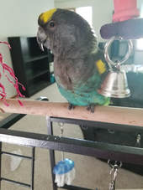
Cricket the Meyers parrot
Cricket is the sweetest most mellow natured boy you could ever meet! He’s got a zest for life, loves food, snacks, things to chew up and the ability to get around despite his ‘little feet’. Cricket was dumped by an owner who decided he wasn’t flashy enough for him and he wanted to get a “better bird”. Little information was left on Cricket and he was left to fend for himself.
Cricket was running around the floor being chased by other birds and attacked, they’d ripped out his wing and flight feathers leaving him no real escape and bite off all his toes. He was unable to climb, balance and grasp normally, nor was he able to fly at the time. We immediately took him in in a heartbeat. He’s been a ball of love ever since and loves to get pets and sit on your hand or shoulder.
We’ve provided special cage accommodations that allow for him to walk around on flat feet since he cannot grasp, and hammocks under areas he could potentially fall from. He has flat perches and plenty of activity. He loves to greet us every day and is happy for a head scratch or two. He’s a handsome man estimated to be about 22 years old and will live out the rest of his life here at the sanctuary for whatever that time may be, whether it be another year or another 8 years or more! We’re happy to provide him with love and empathy for the rest of his life and ensure he has no more hardships in his future.

Samson's Story (Now Bo)

Samson was a young pup, originally in a shelter somewhere outside of Washington. As most young pups he was eager to get out of the shelter and go home with a family. Samson was picked to go to bomb training school and start as a working dog. Unfortunately, he failed the intake exam.
He then went home with the trainer in order to calm down and get used to being out of a shelter environment and try again. He started going to work with her in order to learn the ropes and hopefully pass or show some aptitude for bomb sniffing. Samson wasn’t great at finding trouble though, he’d be better suited to eat it if anything haha.

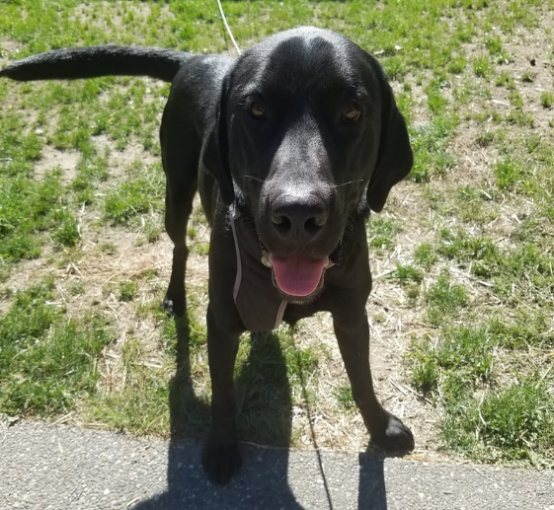
In the end he wasn’t happy with the idea of being a working dog, and the examiner wasn’t interested in Samson as a house dog and felt he was too much work. They didn’t want to work with Samson anymore and had too much on their plate to deal with a barely 1 year old, 75lb black lab puppy. So off to Melt My Heart he was sent.
Upon arrival we knew instantly he was an absolute love. Samson showed immediately that all he wanted to do was play, whether it be cat, dog, person, bird – sometimes he wanted to play too much but he’s a puppy and that was expected. He was a model pup and even when he was hyper was eager to fit in with everyone. Samson quickly learned about potty training, and crate training. He was tested with all types of other dogs and taken out on trips. He did amazing on car rides and showing off how cute he was. It didn’t take long before he was off to his final vet visit to and to meet a special family.
His final vet visit got him up to date on shots, microchip, a health check-up, some routine de-wormer, and some prescription food to go home since all the changes had his tummy in butterflies. When he met his family, he was all smiles, tail wags and kisses!
It was pretty evident right away that the ENTIRE family was willing to participate in Samson’s care, training, exercise and managing his transition. His new life started with a brand new name, Bo. They also had a great local support system that was already involved and ready to assist with training, play dates and puppy sitting. When we popped the question of adoption and they accepted immediately we knew Bo had found the perfect family. We love the updates and hope he has a happy forever life with his 2 human siblings, 2 cat siblings (who are still warming up to a big ol hyper boy) and his older pup sister (another lab).
​Thank you for giving Bo (Was Samson) the dream home he was begging for!

Resources & Financial Management
The fact is there is more than just food and love required for animals, especially those with special needs. We have extensive veterinary bills as well. Every donation of supplies, food, labor and love helps divert resources elsewhere to make this rescue work.
Thank You to All of Our Donors
We are eternally grateful for those who came out early in our first year to help us with our vision. As it was our first year there was extensive work to be done to make our facility comfortable for our residents as well as care for them. The cash donations of the following donors came at a time when it was most needed and we are all thankful.
Cash Donations |  |  | 1st year Expenses
Molly M. | $375.00 |  | Facility Improvement | $ 4,593.72
Carol R. | $200.00 |  | Veterinary Care | $ 4,472.76
Theresa C. | $100.00 |  | Resident Feed | $ 2,628.52
Lisa O. | $100.00 |  | Shelter Development | $ 2,000.12
Lynda D. | $50.00 |  | Resident Toys | $ 486.45
Melanie D. | $50.00 |  | Legal/Administrative | $ 433.95
Jennie H. | $50.00

Special thank you to the business that support us!
We are eternally grateful for the local organizations who help us through generous non-cash donations
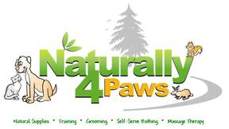
Executive Leadership
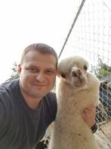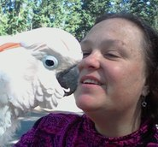
Lorelei Kushaney
Board Chair/Founder
Chele Dimmett
Treasurer

Eric Kushaney
Board Member
Lorelei has been in love with animals from the moment she was born. She began working professionally with them from the age of 12. She has worked with a vast array from exotics, birds of all types, equine, and domestic pets. | Eric has always had a heart for animals and the animals have taken to him instantly no matter what their background or fears were. He has a background of working with and boarding animals, mostly with dogs. He even grew up with 5 Great Pyrenees in the household all at once | Chele has had the heart to nurture others around her no matter it be animal or human. She is a natural at calming the nature of those in distress and can communicate directly to the heart. She has experience rehabbing parrots, as well as having owned cats and dogs
Our Amazing Volunteers
Synclair – Synclair is a lovely young woman who dedicates much of her free time to helping care for the animal’s basic needs, providing what she can for them and socialization. She has helped them learn to trust from the very beginning and they always look forward to seeing her come through the doors eagerly. We know her future will always include looking out for animals and seeing the best in all of them and helping them to find love.

Beverly – This woman has been reliable and there for the animals through and through from day one that she came, she has dedicated every Friday to helping with their care and needs in whatever way she can. She has become an integral part of our functions and the animals know her as one of their very own.

Looking Forward
Our future is ever growing, and we see our pastures continuing to grow and develop, our facilities to be upgrade and our enclosures to grow. We hope to become even closer within the community and build our volunteer base. Our goals is to become an integral partner with other groups in order to build the network to better help animals in need and reach those who need us most. We greatly enjoy having animals assist humans as well by partnering with groups in order to build character, educate and heal for both humans and animals alike.
We Need Your Help
Every Penny Matters
​We welcome donations of all kinds to help support upkeep costs of the sanctuary, prepare for new arrivals, manage vet and medical care and much more!

paypal.me/MeltMyHeartRS | www.patreon.com/MeltMyHeart
smile.amazon.com
Use code MELTMYHEART20 while you shop save 20% and automatically donate 20% | Wishlist: http://a.co/bLf4xVm
https://www.pinterest.com/kyokomitsu/animal-rescue-%2B-sanctuary-wishlist/
Top of Form
Volunteer
We always could use a few extra hands around the property helping out, whether that's to love on or socialize them, or to help clean out the cages, or even learn and assist with the grooming we welcome volunteers! We also could use some builders to help set up and maintain the property.
Foster
If you'd rather volunteer from home we always need fosters to welcome new rescues into their home temporarily when they come in need. You can apply to be a foster on file for any type of animal or species of your choosing so that when a life is in need, we're ready! Just message us for a foster application!
​
Educate
We're always looking for more people to learn about the residents and educate others as to bring awareness. Courses are coming soon that you can take in order to better educate and spread awareness of care, needs, and concerns throughout the community. We're also here to help educate you on proper care of individual animals.
Partnership
Are you a rescue or local community looking to partner? Contact us with your needs today! The more we work together, the better it is for the animals.
Sanctuary + Therapy
Are you looking for a local therapy animal group? Do you work with kids, elderly, special needs, mental health or veterans and need a friendly group of animals to come visit your community? Schedule with us today, for a session with our approved residents who can visit in the community!

2017

Annual Report
nn

Connect With Us! .
(559) 470-3098 | MeltMyHeartSanctuary@outlook.com

