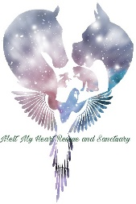
Melt My Heart Rescue and Sanctuary Goat Application
Thank you for your interest in adopting rescues from MMHRS! Please fill out our adoption inquiry application to begin the evaluation process. After completing this application please email photos of both your fencing and shelter to meltmyheartsanctuary@outlook.com. Once your application and photos are reviewed, which can take up to a few days, we will contact you to discuss further. If your home looks like it will be a good fit, a time will be scheduled for you to meet with our adoptable. If all is a fit a home check will be scheduled prior to adoption and adoption contract being signed. Note that the completion of this application does not guarantee the adoption of a MMHRS rescued animal. Please note this is not the official adoption contract.
Please also note:
*We only adopt goats in pairs unless you already have other goats at home. We do occasionally adopt certain adult goats to homes as a horse companion.
*We only adopt goats as pets, we do not adopt goats for milking or breeding, or meat.

Name*
First Name
Last Name
Email *
Phone *
(###)
###
####
Your Full Address *
Tell Us About you
Why do you want goats? *
What experience do you have with livestock? *
About your home
Do you rent or own your property? *
Rent
Own
What type and size of shelter will you be using to house your goats? How close is it to your house? *
What type of fencing do you have and how tall? *
What other animals do you have at the home? *
How often is someone home? *
What are your plans for goat care when you are out of town? *
Are you interested any specific goats from our adoptable goat list? *
Fill in with specific goats names or "no."
How did you hear about us?
(Optional)

